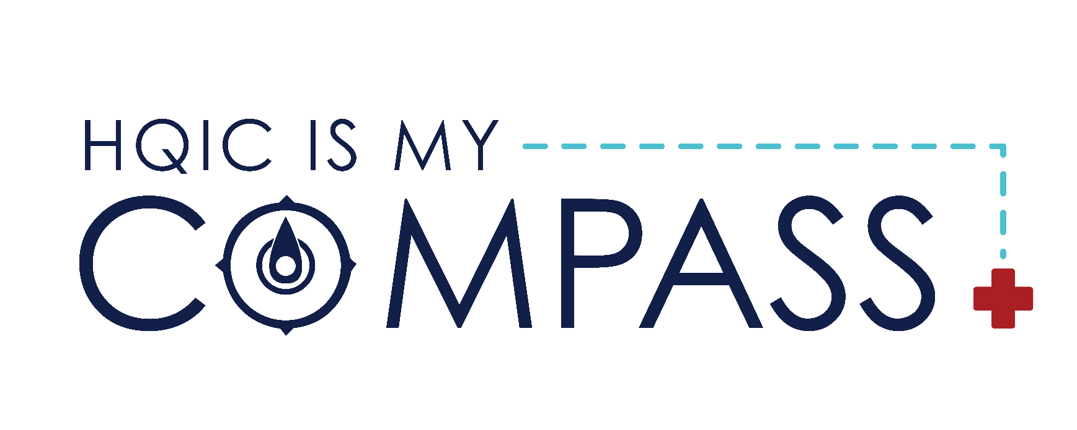
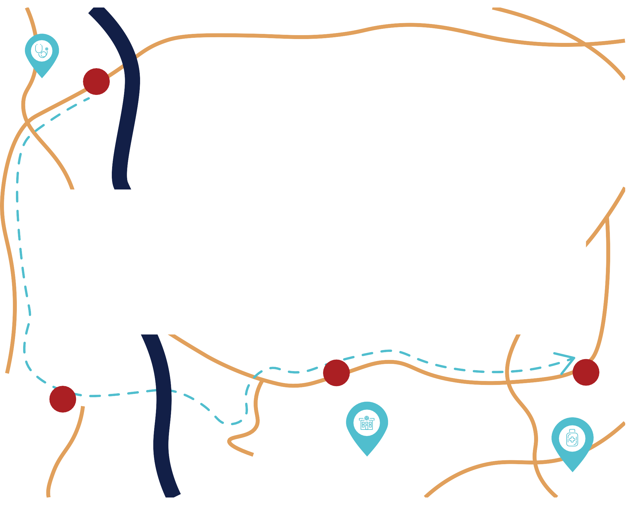

H

Because:

I C
Q

This material was prepared by Compass HQIC Network a Hospital Quality Improvement Contractor under contract with the Centers for Medicare & Medicaid Services (CMS), an agency of the U.S. Department of Health and Human Services (HHS). Views expressed in this material do not necessarily reflect the official views or policy of CMS or HHS, and any reference to a specific product or entity herein does not constitute endorsement of that product or entity by CMS or HHS. 12SOW Compass HQIC Network/Hospital Quality Improvement Contractor – [0300] – 03/15/2023.

